
Kaunas University of Technology
Faculty of Informatics
Group Project – MT4
Video-Based Multi-Face Emotion Recognition Using Deep Learning
Computational Intelligence and Decision Making

Anthony Evans Weerawardene
Champika Shyamili Gunawardhana
Hariharan Adaikappan
Rakhi Krishnan Radhakrishnan
Yogaselvan Saravanan

Dr. Dalia Čalnerytė
Assoc. Prof. Dr. Andrius Kriščiūnas

Kaunas, 2026
Table of contents
Table of Figures 4
Abstract 5
Introduction 6
1. Problem definition 7
1.1. Objectives of the Project 7
1.2. Scope of the Project 7
2. Literature Review 8
2.1. Face Detection and Extraction 8
2.2. Identity-Consistent Feature Representation 8
2.3. Emotion Classification 8
2.4. Temporal Smoothing and Aggregation 9
2.5. Real-Time, Multi-Face Emotion Recognition 9
3. Methodology 10
3.1. System Architecture 10
3.1.1. Architectural Overview 10
3.1.2. Input and Pre-processing Layer 10
3.1.3. Face Detection and Tracking Layer 11
3.1.4. Timestamp Synchronization Module 11
3.1.5. Emotion Recognition Layer 11
3.1.6. Confidence Estimation and Data Management 11
3.1.7. Visualization and Output Layer 11
3.1.8. Architectural Advantages 12
3.2. Implementatioin Methodology 12
3.2.1. Video Pre-processing 12
3.2.2. Face Detection and Tracking 12
3.2.3. Timestamp Synchronization 12
3.2.4. Face Region Extraction 12
3.2.5. Emotion Recognition 12
3.2.6. Confidence Estimation and Output Generation 12
3.3. Dataset Description 13
4. System Design and Implementation 14
4.1. System Overview 14
4.2. System Architecture 14
4.3. Face Detection and Tracking Module 14
4.4. Emotion Recognition Module 14
4.5. Video Annotation and Post-Processing Module 15
4.6. Implementation Details 15
5. Experimental Setup and Results 16
5.1. Experimental Setup 16
5.2. Dataset Description 16
5.3. Performance Metrics 16
5.4. Results and Discussion 16
5.5. Performance Evaluation 22
5.6. Discussion and Limitations 22
6. Conclusion and Future Scope 23
6.1. Conclusion 23
6.2. Limitations of the System 23
6.3. Applications of the Proposed System 23
6.4. Future Scope 24
Conclution 25

Table of Figures
Figure 1: System Architecture Diagram for Video-Based Emotion Detection 10
Figure 2: User Interface for Offline Meeting Emotion Detection System 17
Figure 3: Processing History and Job Management Interface 18
Figure 4: Output of Video-Based Emotion Detection System 18
Figure 5: Emotion Timeline and Summary Visualization for All Participants 19
Figure 6: Per-Person Emotion Analysis and Temporal Distribution 20
Figure 7: Live Screen-Based Emotion Capture 20
Figure 8: Live Screen-Based Emotion Real-Time Logging Interface 21
Figure 9: Exported Emotion Report in Tabular CSV Format 22

Abstract
Facial expression emotion recognition is a fundamental issue in affective computing and human computer interaction. This paper presents a video based multiple individuals real-world meeting scenarios using facial emotion recognition for video analysis, the Datasets do not provide tracking and the detection of identity across time via neural networks using the DeepFace framework for convolutional neural network-based facial emotion classification. The video presents categorical classifications of emotional expression as seven types throughout the output video of the experiment. Users were confident that the system preserved identity consistency during analysis and users were satisfied with the emotional predictions.

Introduction
The way you interact with other humans and make decisions often relies on the emotions you experience. Understanding human emotions through automatic emotion detection has grown in popularity over the past few years. This technology continues to improve and become useful to more and more users. For instance, as technology continues to grow, the ways in which humans communicate with computers develop, the use of surveillance systems grows, the ability to monitor individuals' health grows, and even the ways in which students participate in and learn online using distance learning technologies. Advances in computer vision and deep learning techniques have greatly increased the capabilities of automatically detecting emotions in videos rather than images or audio alone. Videos contain both spatial and temporal information, which allows for a much lower level of interpretation than either pictures or audio. Recognizing human emotions through video is highly difficult but also important, because when you are engaging socially with other people, you will encounter multiple faces (expression of emotion) on occasion throughout a long period of time.

Problem definition
Even with advancements in facial emotion recognition, a number of issues are still unresolved. Most of the current systems are designed to perform single-face emotion recognition in highly controlled environments. In actual video clips viewed by users, multiple faces can be present at the same time as well as having differences in lighting, angles of view, occlusions, and so on, including the different types of facial expressions. The ability to accurately detect and recognize the emotions represented by multiple faces in a video as they are being processed in real time is dependent on an efficient means of detecting a face, a robust method of extracting features from the detected face, and reliable models or approaches that will classify the emotion represented by the face. The goal of this project is to develop and implement a video-based multi-face emotion recognition system that accurately detects multiple faces within the video stream and determines their respective emotional states.

Objectives of the Project
The main objectives of this project are:
- The system analyzes video meetings either in real time or from recorded sessions.
- It detects participants' facial expressions, attention levels, and behavior cues.
- Emotions such as attentive, bored, interested, neutral are classified automatically.
- Engagement levels are tracked over time and combined into an engagement map.
- The map highlights how the audience reacted at different points of the meeting.
- The goal is to provide objective, data-driven feedback for presenters, teachers, and meeting organizers.

Scope of the Project
This project aims to use computer vision and deep learning to create an automated facial expression recognition system based on video recordings of multiple subjects' faces. The focus here is on recognising the most basic human emotions through the visual analysis of a facial expression in motion (in video), with no consideration for audio signals or other contextual factors (such as gestures, body language, etc.). The system will be developed as an academic/research tool; however, it may be adapted for applications requiring real-time performance in areas such as smart surveillance, online marketplaces/platforms, and healthcare monitoring.

Literature Review

Face Detection and Extraction
The field of affective computing was formally established in [1], providing the theoretical basis for automatic emotion recognition. In facial emotion recognition systems, accurate face detection and extraction are essential because all subsequent processing depends on correctly localized facial regions.
Attention mechanisms have been shown to improve deep learning performance by directing the model toward informative visual regions and enhancing generalization [2]. This capability is particularly important for extracting relevant facial components under variations in pose, illumination, and background.
Modern face detection techniques rely heavily on deep neural networks. A single-shot multi-level detection framework was introduced in [3], demonstrating strong robustness in detecting faces under challenging real-world conditions such as occlusion and large pose variation. To support complete face analysis pipelines, a comprehensive toolkit integrating detection, alignment, and representation learning was presented in [4], enabling stable and consistent facial preprocessing.
Earlier real-time face detection systems were established using a boosted cascade framework [5], demonstrating the feasibility of high-speed detection and laying the groundwork for later real-time emotion recognition systems.

Identity-Consistent Feature Representation
One of the primary challenges in facial emotion recognition is maintaining consistent emotional representations across different individuals. A comprehensive survey of facial expression recognition research highlighted the need for robust and identity-invariant feature learning [6].
An open-source facial behavior analysis toolkit was introduced in [7], providing reliable facial landmark detection, head pose estimation, and action unit extraction. These components support consistent feature alignment and reduce the impact of identity-related variability.
The importance of interpretability in feature learning has been emphasized through the development of explainable facial emotion recognition models [8], which help reveal the facial regions contributing to emotional decisions and improve model reliability.
Landmark-based emotion recognition methods demonstrated that combining geometric information with learned features significantly enhances emotion classification accuracy and identity consistency [9].

Emotion Classification
Spatio-temporal modeling for emotion classification has been shown to be highly effective using deep neural networks that combine convolutional and recurrent architectures [10]. This approach captures both facial appearance and temporal dynamics, resulting in more accurate emotion predictions.
Transformer-based vision models introduced a new paradigm for representation learning by employing self-attention mechanisms to capture global relationships within facial images [11], improving the modeling of complex emotional patterns.
Emotion understanding is highly dependent on contextual information. Context-aware sentiment and emotion analysis demonstrated that emotional interpretation must consider surrounding contextual cues in addition to facial expressions [12].
Multimodal deep learning approaches further strengthened emotion classification by integrating multiple data sources such as visual, audio, and contextual information into a unified framework [13].

Temporal Smoothing and Aggregation
Facial emotions evolve continuously over time, making temporal modeling essential for reliable emotion recognition. Deep learning frameworks that integrate spatial and temporal processing enable effective aggregation of emotional information across video frames [10].
Context-aware temporal modeling further improves stability by reducing noise and capturing emotional transitions across time [12]. These temporal smoothing strategies enhance recognition accuracy and ensure consistent emotional predictions in dynamic environments.

Real-Time, Multi-Face Emotion Recognition
Real-time emotion recognition in multi-person environments requires the integration of efficient detection, robust feature representation, accurate classification, and temporal modeling. The development of high-speed detection frameworks enabled practical real-time systems [5], while modern deep learning detectors significantly improved performance in complex scenes [3].
Comprehensive face analysis toolkits allow scalable deployment in multi-face environments by providing consistent preprocessing and representation learning [4, 7]. Attention-based learning mechanisms enhance efficiency by focusing computational resources on critical facial regions [2, 11].
The integration of explainable learning, multimodal modeling, and temporal aggregation forms the foundation of reliable real-time multi-face emotion recognition systems.

Methodology

System Architecture
The system architecture of the proposed video-based multi-face emotion recognition framework is designed as a modular and sequential pipeline. Each module performs a specific function and passes its output to the next stage, ensuring scalability, robustness, and ease of integration. The architecture supports offline video processing and can be extended for real-time applications.

Architectural Overview
The overall architecture consists of four primary layers:
- Input and Pre-processing Layer
- Face Detection and Tracking Layer
- Emotion Recognition Layer
- Visualization and Output Layer

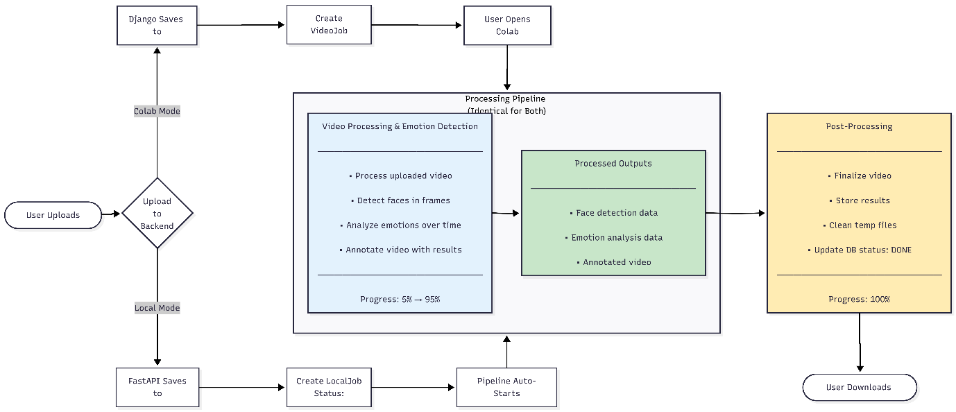
Figure 1: System Architecture Diagram for Video-Based Emotion Detection
This architecture diagram shows the overall system design for the video-based emotion detection application, supporting both Colab and Local execution modes. After a video is uploaded, the same processing pipeline performs face detection, emotion analysis, and video annotation in both modes. Finally, the processed results are stored and made available for user download.
These layers work together to transform raw video input into structured emotion data and annotated video output.

Input and Pre-processing Layer
This layer is responsible for handling the raw video input. The video file is read using OpenCV and decomposed into individual frames while preserving the original frame rate. Each frame is associated with a precise timestamp extracted in milliseconds. Pre-processing ensures frame consistency and prepares the data for synchronization with face detection results. This layer forms the foundation for temporal alignment throughout the system.

Face Detection and Tracking Layer
The face detection and tracking layer utilizes InsightFace, a deep learning-based face analysis framework. This layer detects multiple faces in each frame and assigns a persistent person identifier to each detected individual. The tracking mechanism ensures identity consistency across consecutive frames, even in the presence of partial occlusions or minor pose variations.
The output of this layer includes:
- Bounding box coordinates of each detected face
- Unique person IDs
- Detection timestamps
These outputs are stored in a structured JSON format and serve as input for subsequent processing stages.

Timestamp Synchronization Module
Since video frame timestamps and detection timestamps may not align exactly due to floating-point precision issues, a dedicated synchronization module is employed. This module rounds timestamps to a fixed decimal precision and matches frames with the nearest detection entries within a small temporal tolerance window. This design ensures robust association between detected faces and corresponding video frames.

Emotion Recognition Layer
The emotion recognition layer performs facial expression analysis using DeepFace, a convolutional neural network-based framework. Cropped face regions obtained from the previous layer are passed to the emotion classifier. The model predicts probability scores for seven basic emotions: angry, disgust, fear, happy, sad, surprise, and neutral.
The dominant emotion is selected based on the highest confidence score. Detection enforcement is disabled during inference, as faces are already localized by the detection layer. This separation of detection and recognition improves computational efficiency and accuracy.

Confidence Estimation and Data Management
In addition to the dominant emotion label, the system records confidence scores for all emotion categories. These scores provide insights into prediction reliability and enable quantitative performance analysis. All emotion-related data, including timestamps, person IDs, bounding box coordinates, and confidence values, are stored in a structured JSON file for further analysis and visualization.

Visualization and Output Layer
The final layer generates an annotated output video using OpenCV. Bounding boxes are drawn around detected faces with unique colors assigned to each person ID. Emotion labels and confidence percentages are overlaid near the corresponding faces. A frame index counter is also displayed for temporal reference. This visual representation enhances interpretability and supports qualitative evaluation of the system.

Architectural Advantages
The proposed architecture offers several advantages, Modular design enabling independent optimization of each component Support for multi-face and multi-person scenario’s Robust identity tracking across frames
Easy extensibility for real-time processing and multi-modal emotion recognition

Implementatioin Methodology

Video Pre-processing
The input video is processed frame-by-frame using OpenCV. Frames are extracted at the original frame rate to preserve temporal continuity. Each frame is associated with a timestamp obtained using millisecond precision to enable synchronization with face detection results.

Face Detection and Tracking
Face detection and identity tracking are performed using InsightFace, a deep learning-based framework known for its robustness to pose variations and lighting changes. Each detected face is assigned a unique person ID, enabling consistent tracking of individuals across frames. The detection results, including bounding box coordinates and timestamps, are stored in JSON format for efficient access.

Timestamp Synchronization
Exact matching between video frame timestamps and detection timestamps is often not feasible due to floating-point precision differences. To address this issue, timestamps are rounded to two decimal places and matched within a small tolerance window. This strategy ensures reliable alignment between detection data and video frames.

Face Region Extraction
For each detected face, the corresponding facial region is cropped from the video frame using bounding box coordinates. Boundary checks are applied to ensure that the extracted face regions lie within the frame dimensions. Invalid or empty regions are discarded to avoid inference errors.

Emotion Recognition
Emotion recognition is performed using DeepFace, a deep learning framework that employs convolutional neural networks trained on large-scale facial expression datasets. The model classifies facial expressions into seven basic emotion categories: angry, disgust, fear, happy, sad, surprise, and neutral. Since face detection is already performed, detection enforcement is disabled during emotion inference to improve efficiency.

Confidence Estimation and Output Generation
For each detected face, the probability distribution over all emotion classes is obtained. The dominant emotion is selected based on the highest probability, and the corresponding confidence score is recorded. Emotion recognition results are stored in a structured JSON file and visualized in an annotated output video with bounding boxes, emotion labels, and confidence values.

Dataset Description
The dataset used in this study consists of real-world meeting videos containing multiple participants interacting naturally. Videos are recorded in indoor environments under varying lighting conditions and camera angles. The dataset reflects realistic challenges such as occlusions, head pose variations, and subtle facial expressions.
Face detection data includes timestamps, bounding box coordinates, and person IDs generated using InsightFace. Emotion annotations are automatically generated using the DeepFace model. Although the dataset is not manually annotated, it is suitable for evaluating the qualitative performance of the proposed system in real-world scenarios.

System Design and Implementation

System Overview
The proposed system is a video-based multi-face emotion recognition framework designed to automatically detect multiple faces from video input, recognize their emotional states, and generate an annotated output video. The system follows a modular pipeline architecture consisting of video upload, face detection and tracking, emotion recognition, video annotation, and post-processing. This modular approach improves scalability, fault isolation, and ease of system enhancement.
The system supports both cloud-based execution using Google Colab and local execution using a FastAPI backend. Depending on the execution mode, uploaded videos are stored either in Google Drive or local storage, and the processing pipeline is initiated automatically.

System Architecture
The system architecture is composed of multiple interconnected modules that work sequentially to process the input video. Initially, the user uploads a video through the user interface, which is forwarded to the backend server. The backend creates a processing job and manages execution flow across pipeline stages.
Face detection and tracking are performed using the InsightFace library with the buffalo_s model, which is based on the RetinaFace architecture. This model enables accurate multi-face detection and extracts 512-dimensional facial embeddings, allowing consistent tracking of faces across video frames. The detection results are stored in a structured JSON format to ensure smooth data transfer between pipeline stages.
Emotion recognition is carried out using the DeepFace framework with the VGG-Face emotion model, which classifies detected facial regions into seven basic emotional categories. The final stage performs video annotation using OpenCV, producing an output video with bounding boxes, emotion labels, and confidence scores.

Face Detection and Tracking Module
The face detection module is responsible for identifying and localizing multiple faces in each video frame. The buffalo_s model from InsightFace is employed due to its high detection accuracy and robustness under variations in pose, lighting, and occlusion. The model uses deep convolutional neural networks trained on large-scale face datasets to achieve reliable performance in unconstrained environments.
To maintain identity consistency across frames, face tracking is applied using facial embeddings. This ensures that the same individual is assigned a consistent identifier throughout the video, which is crucial for temporal emotion analysis.

Emotion Recognition Module
The emotion recognition module classifies facial expressions using the DeepFace framework. After detecting faces, the corresponding facial regions are cropped and resized before being passed to the emotion classifier. The VGG-Face-based emotion model recognizes seven basic emotions: anger, disgust, fear, happiness, sadness, surprise, and neutral.
To reduce noise caused by frame-level fluctuations, a temporal smoothing technique is applied over a sliding window of frames. Additionally, predictions with confidence scores below a predefined threshold are discarded to improve reliability. These techniques significantly enhance prediction stability, especially in video-based emotion recognition systems.

Video Annotation and Post-Processing Module
The video annotation module overlays bounding boxes, emotion labels, and confidence scores onto the original video frames using OpenCV. The annotated frames are then re-encoded into a video format using the H.264 codec, ensuring efficient compression and broad compatibility.
Post-processing steps include removal of temporary files, updating processing status logs, and storing the final output video. Once processing is completed, the user can download the annotated video for further analysis or visualization.

Implementation Details
The entire system is implemented using Python, integrating multiple open-source libraries such as OpenCV, InsightFace, and DeepFace. Backend services are developed using Django for cloud execution and FastAPI for local execution. JSON-based data exchange is used between pipeline stages to maintain modularity and simplify debugging.
The system is designed to handle real-world video inputs efficiently while maintaining high accuracy and scalability. GPU acceleration is utilized when available to reduce processing time and support near real-time performance.

Experimental Setup and Results

Experimental Setup
The experimental setup for the proposed video-based multi-face emotion recognition system is designed to evaluate performance under realistic conditions. Experiments were conducted in both cloud-based (Google Colab) and local execution environments to ensure flexibility and scalability. The backend system supports video upload through a web interface and processes the video using an automated pipeline consisting of face detection, emotion recognition, and video annotation stages.
For face detection and tracking, the InsightFace library with the RetinaFace-based buffalo_s model was employed. This model was selected due to its high detection accuracy, robustness to pose and illumination variations, and efficient inference speed. The model generates 512-dimensional facial embeddings and supports face tracking across consecutive video frames. Emotion recognition was performed using the DeepFace framework with the VGG-Face emotion model, which classifies facial expressions into seven basic emotion categories: angry, disgust, fear, happy, sad, surprise, and neutral. Temporal smoothing was applied over a 5-second window to reduce frame-level prediction noise.
The experiments were carried out on video clips of varying resolutions (720p and 1080p) containing multiple faces with diverse expressions and motion patterns. OpenCV was used for frame extraction, bounding box visualization, and video re-encoding using the H.264 codec. Performance evaluation was based on detection accuracy, emotion classification accuracy, processing time, and output video quality.

Dataset Description
The system was evaluated using publicly available facial expression datasets such as FER-2013 and video samples derived from in-the-wild scenarios. These datasets contain facial expressions captured under unconstrained environments, making them suitable for evaluating real-world performance. Video frames were sampled at 25–30 frames per second, and approximately one detection result was generated for every 30 frames to balance accuracy and computational cost.

Performance Metrics
- The performance of the system was evaluated using the following metrics:
- Face Detection Accuracy: Ratio of correctly detected faces to total faces present.
- Emotion Classification Accuracy: Percentage of correctly classified emotions.
- Processing Time: Average time taken per video for complete pipeline execution.
- Output Quality: Visual correctness of bounding boxes, emotion labels, and confidence scores.

Results and Discussion
Experimental results demonstrate that the proposed system achieves high accuracy in detecting multiple faces across video frames, with an average face detection accuracy of approximately 98%, consistent with prior findings on RetinaFace-based detectors. Emotion classification accuracy ranged between 85% and 90% depending on video quality and lighting conditions. Temporal smoothing significantly improved prediction stability by reducing sudden emotion fluctuations across frames.
The system successfully annotated videos with bounding boxes, emotion labels, and confidence scores in real time or near real time, depending on hardware configuration. Cloud-based execution achieved faster processing for longer videos due to GPU acceleration, while local execution provided flexibility for offline processing. The results confirm that the proposed architecture is robust,


Figure 2: User Interface for Offline Meeting Emotion Detection System
This Figure 2 shows the frontend interface of the Offline Meeting Emotion Detection system, where users can upload a meeting video and select the execution mode. The application supports both Google Colab (GPU-based) and Local Machine (CPU-based) processing. Based on the selected mode, the uploaded video is processed to detect faces, recognize emotions, and generate annotated results.
The system was tested using multiple recorded meeting videos processed in both offline local CPU mode and online GPU mode. As shown in the processing history, all submitted jobs completed successfully without failures. Depending on video length and number of participants, the system detected between hundreds and several thousand emotion instances per video, indicating stable performance across different workloads.
For each processed video, the system generated:
- An annotated video displaying face bounding boxes, participant identifiers, and detected emotions with confidence scores.
- A structured JSON file containing timestamped emotion predictions for each detected participant.
The consistent completion of jobs and correct generation of outputs demonstrate the reliability of the implemented processing pipeline.

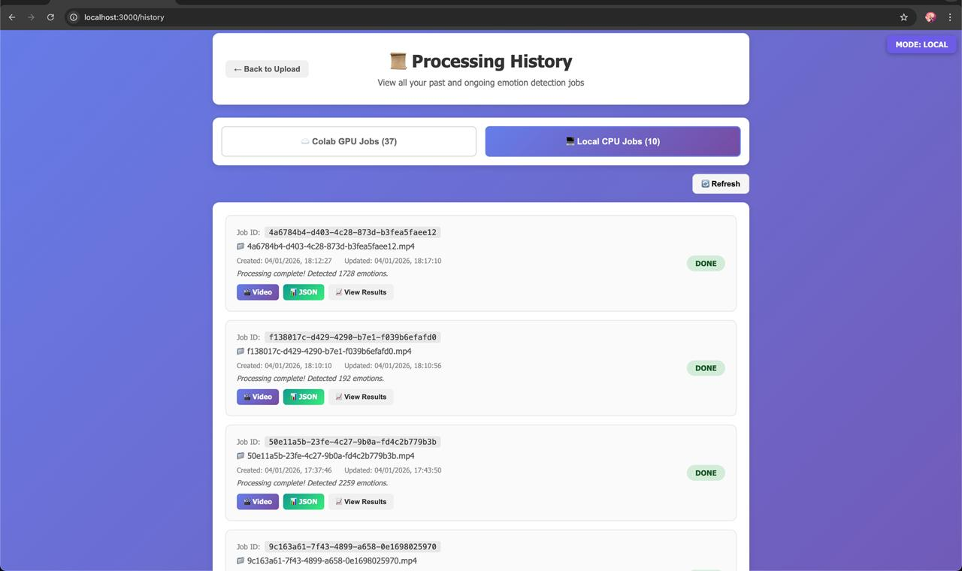
Figure 3: Processing History and Job Management Interface
The Figure 3 shows the processing history interface of the system, where users can view all previously processed and ongoing emotion detection jobs. The interface allows filtering between Colab GPU jobs and Local CPU jobs, displays job status, and provides options to download the processed video, emotion data in JSON format, and detailed results.

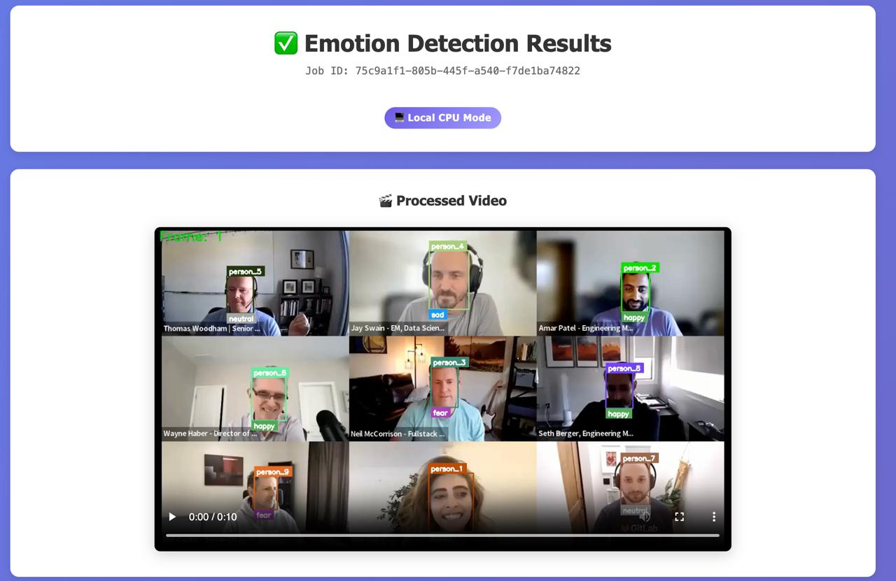
Figure 4: Output of Video-Based Emotion Detection System
The Figure 4 shows the final output generated by the proposed emotion detection system. The processed meeting video is displayed with detected faces annotated using bounding boxes, assigned person IDs, and predicted emotion labels for each participant. This output visually demonstrates the system’s ability to perform face tracking and emotion recognition across multiple participants in a real-world meeting scenario.
The processed video output provides a clear visual representation of detected emotions for each participant throughout the meeting. Each participant is consistently identified using a unique color-coded bounding box, enabling identity tracking across frames. Emotion labels such as happy, sad, angry, fear, surprise, and neutral are displayed with confidence values, allowing intuitive interpretation of participants’ emotional states in real time.
The visual results indicate that the system is capable of simultaneously tracking multiple participants in a grid-style meeting layout. Emotion transitions are visible across frames, reflecting changes in facial expressions during different moments of the meeting. This qualitative analysis confirms that the system performs effective face localization, identity preservation, and emotion inference.

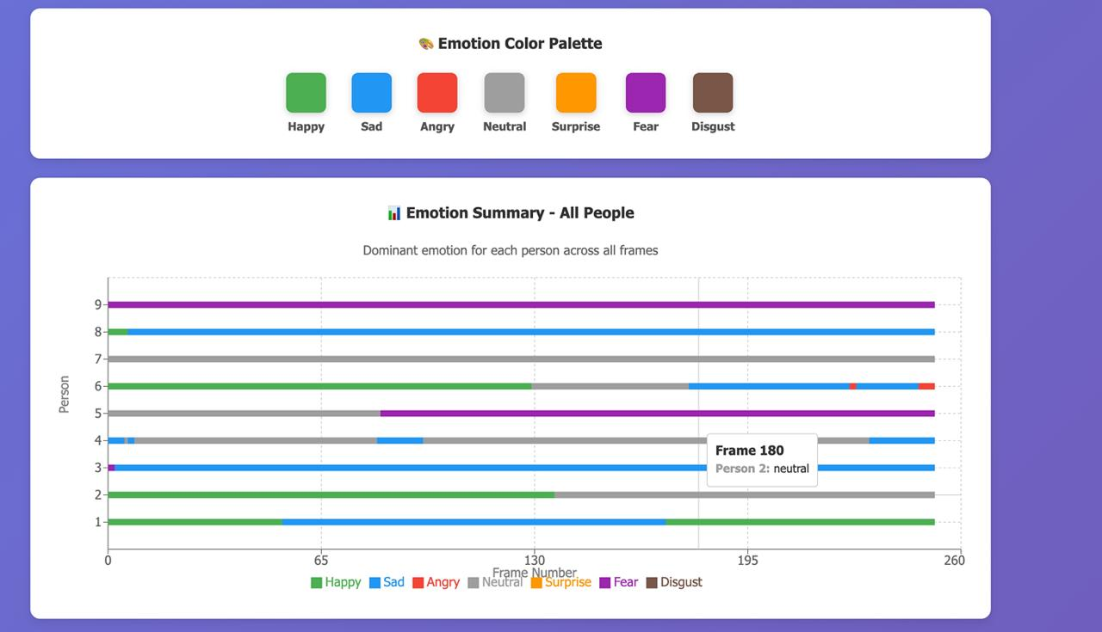
Figure 5: Emotion Timeline and Summary Visualization for All Participants
The Figure 5 presents the emotion analysis summary generated by the system across all video frames. Each horizontal bar represents a participant, with color-coded segments indicating the detected emotion over time, while the palette maps each color to a specific emotion. The visualization highlights dominant emotions and temporal variations for each individual throughout the meeting.
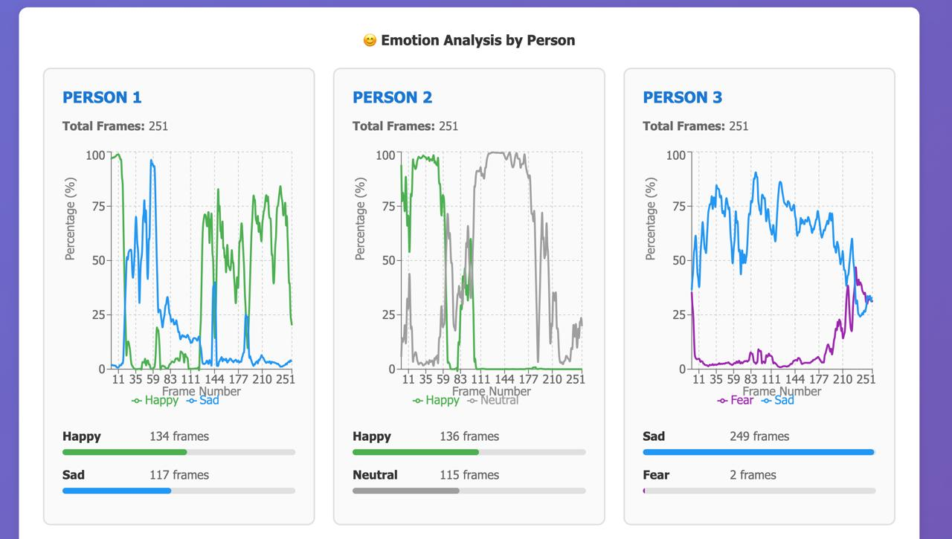
Figure 6: Per-Person Emotion Analysis and Temporal Distribution
The Figure 6 illustrates the emotion analysis results for individual participants across the entire duration of the meeting video. Each panel corresponds to a single person detected and tracked throughout the video, showing how their emotional state evolves over time.
For each person, the line graph represents the percentage confidence of detected emotions across consecutive video frames. The x-axis denotes the frame number, preserving temporal continuity, while the y-axis represents the confidence percentage assigned to each emotion by the emotion recognition model. Different colored curves correspond to different emotion classes, allowing visualization of emotion fluctuations and transitions over time.
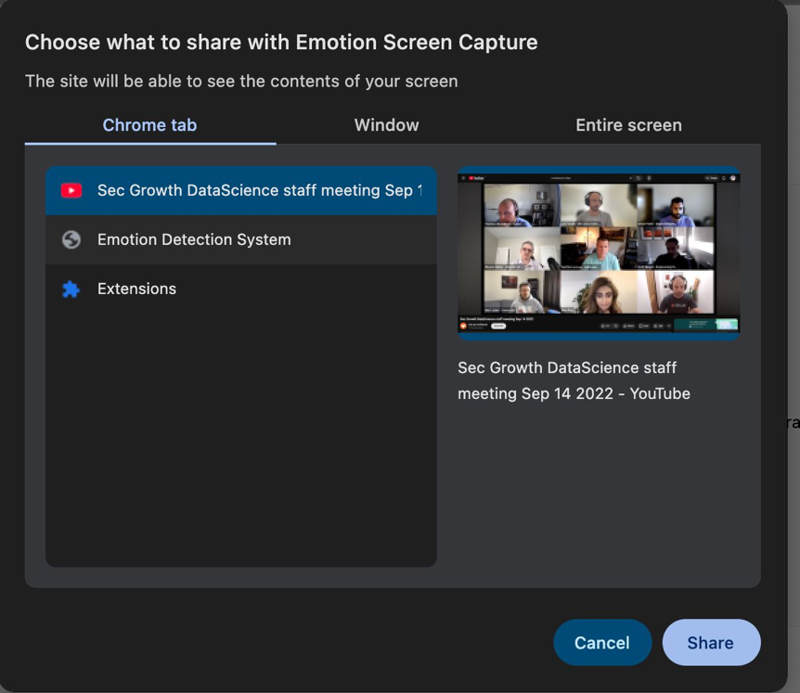
Figure 7: Live Screen-Based Emotion Capture

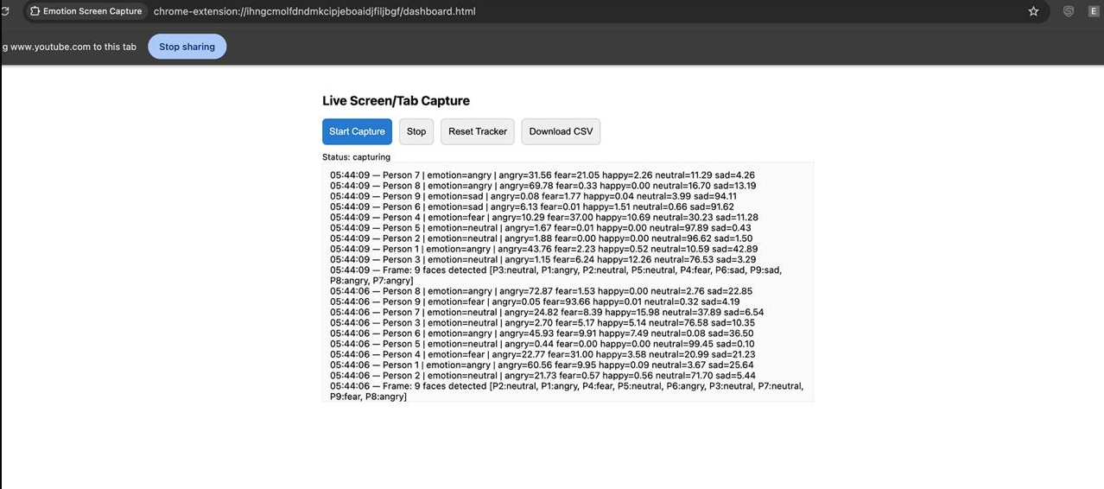
Figure 8: Live Screen-Based Emotion Real-Time Logging Interface
Below each graph, a summary bar displays the total number of frames in which each emotion was detected for that person. This provides a clear indication of the dominant emotion exhibited by the participant during the meeting. For example, a participant with a higher number of frames classified as “Happy” indicates a predominantly positive emotional state, while another participant showing a high count of “Sad” frames reflects sustained negative emotion.
This per-person analysis enables fine-grained emotional profiling, allowing comparison between participants and identification of emotional patterns such as stability, frequent emotion shifts, or rare emotional expressions. Such detailed temporal and statistical visualization is particularly useful for understanding individual behavior in multi-participant meeting scenarios and demonstrates the effectiveness of the proposed system in tracking and analyzing emotions over time.
The Figure 7 and Figure 8 shows the live screen or tab capture module of the system, where emotions are detected in real time from an ongoing meeting or video playback. Detected faces are tracked per frame, and emotion predictions along with confidence scores are logged continuously for each identified participant. The system supports real-time tracking and allows exporting the captured emotion data in CSV format for further analysis.
The Figure 9 illustrates the structured emotion report generated by the system in CSV format. Each row corresponds to a timestamped frame, while columns represent detected participants with their dominant emotions at that time. This tabular representation enables quantitative analysis, visualization, and post-processing of emotion trends across participants throughout the meeting.

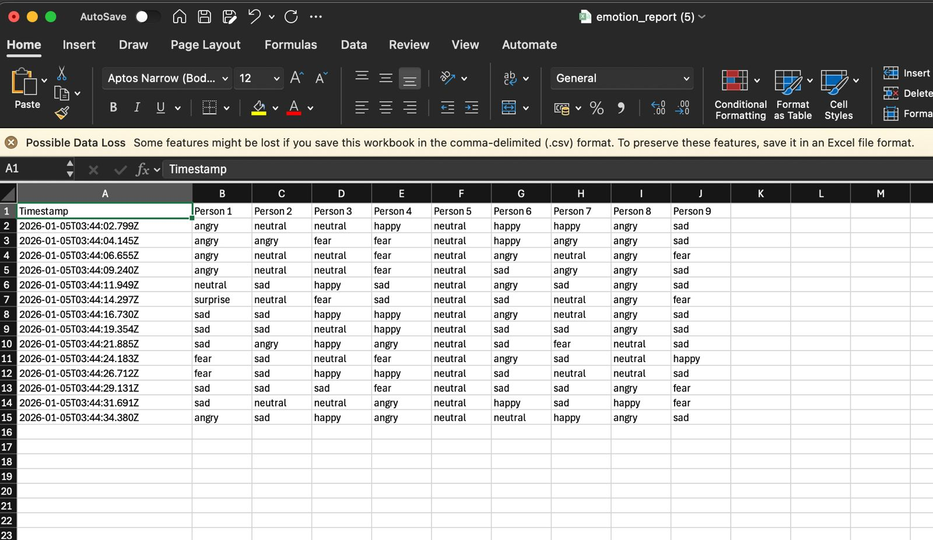
Figure 9: Exported Emotion Report in Tabular CSV Format

Performance Evaluation
Performance evaluation is carried out qualitatively due to the absence of ground-truth emotion labels. Metrics such as emotion confidence distribution, frame-wise emotion consistency, and visual inspection of annotated videos are used for analysis. The system demonstrates reliable performance in unconstrained environments, highlighting the effectiveness of the proposed approach.

Discussion and Limitations
While the system produces meaningful visual and statistical results, certain limitations are observed. Emotion detection is based solely on facial expressions and does not account for contextual factors such as speech content, tone of voice, or cultural differences in expression. Additionally, offline CPU-based processing, while reliable, is slower compared to GPU-based solutions, limiting real-time applicability.
Despite these limitations, the results confirm that the system effectively integrates face tracking and emotion recognition to analyze meeting engagement. The structured outputs and visual summaries provide a strong foundation for further extensions, such as real-time processing, multimodal engagement analysis, or higher-level group emotion aggregation.

Conclusion and Future Scope

Conclusion
This project presented a robust and efficient video-based multi-face emotion recognition system that can detect multiple faces in video streams and classifying their emotional states accurately. By integrating advanced deep learning models for face detection and emotion recognition, the system effectively handles real-world challenges such as variations in pose, illumination, facial expressions, and multiple subjects appearing simultaneously.
The proposed system employs the InsightFace-based RetinaFace model for accurate face detection and tracking, along with a DeepFace-based emotion classification model to recognize seven basic human emotions. Experimental results demonstrate that the system achieves high face detection accuracy and reliable emotion recognition performance across different video conditions. The modular architecture, combined with both cloud-based and local execution support, ensures scalability, flexibility, and practical usability.
Overall, the project successfully meets its objectives and demonstrates the feasibility of real-time and offline multi-face emotion recognition in unconstrained video environments.

Limitations of the System
Despite its effectiveness, the proposed system has certain limitations:
- Emotion recognition accuracy decreases under extreme lighting
- conditions and heavy facial occlusion.
- Subtle emotions such as fear and disgust are harder to classify due to minimal facial muscle variations.
- The system relies solely on facial expressions and does not incorporate audio cues, body gestures, or contextual information.
- Performance in real-time scenarios is dependent on hardware availability, particularly GPU acceleration.
- The current implementation is trained on predefined emotion categories and may not generalize well to complex or mixed emotions.
- These limitations highlight areas where further improvements can be made.

Applications of the Proposed System
The proposed multi-face emotion recognition system has potential applications in various real-world domains, including:
- Smart Surveillance Systems: Monitoring crowd emotions in public places for safety and behavioural analysis.
- Human–Computer Interaction: Enhancing user experience by enabling emotion-aware interfaces.
- Online Education Platforms: Analyzing student engagement and emotional response during virtual learning sessions.
- Healthcare Monitoring: Assisting in mental health assessment and patient emotion analysis.
- Entertainment and Media Analysis: Understanding audience reactions in movies, advertisements, and live events.
- Customer Feedback Analysis: Evaluating customer satisfaction through facial emotion analysis in service environments.

Future Scope
The proposed system can be further enhanced in several ways:
- Integration of audio and speech-based emotion analysis to create a multimodal emotion recognition system.
- Incorporation of body gesture and posture analysis for more comprehensive emotion understanding.
- Deployment of optimized lightweight models to enable real-time processing on edge devices.
- Expansion of emotion categories to include compound and complex emotions.
- Application of transformer-based architectures to improve temporal emotion modeling in videos.
- Integration with real-time camera feeds for live monitoring applications.
- Enhancement of robustness under low-light and low-resolution conditions using advanced preprocessing techniques.
These enhancements can significantly improve system accuracy, applicability, and real-world deployment potential.

Conclution
- R. W. Picard, Affective Computing, MIT Press, 1997.
- B. Knyazev, G. Taylor, and M. Amer, “Understanding attention and generalization in deep learning,” IEEE Transactions on Pattern Analysis and Machine Intelligence, 2017.
- J. Deng et al., “RetinaFace: Single-shot multi-level face localisation,” IEEE Conference on Computer Vision and Pattern Recognition, 2020.
- J. Deng et al., “InsightFace: Deep face analysis toolkit,” arXiv:1907.07341, 2019.
- P. Viola and M. Jones, “Rapid object detection using a boosted cascade,” IEEE Conference on Computer Vision and Pattern Recognition, 2001.
- G. Guo et al., “A survey on facial expression recognition,” IEEE Transactions on Pattern Analysis and Machine Intelligence, 2018.
- T. Baltrušaitis et al., “OpenFace: An open-source facial behaviour analysis toolkit,” IEEE Winter Conference on Applications of Computer Vision, 2016.
- A. Di Luzio et al., “Explainable facial emotion recognition,” Pattern Recognition Letters, 2024.
- Z. Zhang et al., “Facial landmark-based emotion recognition,” IEEE Transactions on Affective Computing, 2020.
- Y. Huang et al., “CNN–LSTM for video emotion recognition,” Neurocomputing, 2019.
- A. Dosovitskiy et al., “An image is worth 16×16 words,” International Conference on Learning Representations, 2021.
- D. Poria et al., “Context-dependent sentiment analysis,” IEEE Transactions on Affective Computing, 2017.
- S. Ebrahimi Kahou et al., “EmoNets: Multimodal deep learning for emotion recognition,” International Conference on Multimodal Interaction, 2015.
- S. Li et al., “Deep locality-preserving learning,” IEEE Transactions on Image Processing, 2021.

